Tool: Creating a Soundscape exemplar

The term soundscape refers to the arrangement of sounds – created with the use of voice, objects and/or instruments – in order to express or accompany a particular scene, dance or series of actions. An arrangement of sounds involves the use of rhythm, silence, motif, pitch, volume and mood.

The following exemplar describes the creation of a soundscape for a particular scene in the story of Awarua and Rereroa, as part of a performance research project to create space for culturally responsive practice using the arts-in-collaboration (St Theresa’s primary school, Plimmerton, 2010).

Step 1: Identify the moment(s) in a story or performance that could best be expressed through, or enhanced by, a soundscape.

Students identified a number of moments in the Awarua and Rereroa story that made reference to sounds. The following section of the story made up the dramatic climax of the story, and contained the strongest sound clues:
Awarua took a deep breath and focused to the north end of [Porirua] Harbour. She gathered speed slowly but surely, her wings flapped furiously. As she picked up the pace, her tail was flapping behind her, leaving a trail behind. As Awarua began to skim across the water, she raised her head thrusting all her energy into her wings.
“Do you see, do you see me fly?” she screeched excitedly.
Awarua was so excited she was flying! She was busy howling at the top of her lungs and didn't see Mana Island looming in front of her. She hit the Island with a mighty crash, sliding across it as if it were slipping through mud at low tide. She landed in the sea nearby […]

Step 2: Brainstorm about what objects, instruments (including the voice) could be used to create the sounds needed.

“Her wings flapped furiously”
The students came up with several ideas to create flapping sounds, such as use rubbish bags, old newspapers paper, cardboard flaps, and tarpaulin sheet.

“Do you see, do you see me fly?”
This could be a song.
“She hit the Island with a mighty crash, sliding across it as if it were slipping through mud at low tide. She landed in the sea nearby…”
Crashing sounds: use drums, sticks, old pots and pans, screams, ripping newspaper, using a toddlers swimming pool filled with water and throw in ice cream containers filled with water to create splashing, crashing and sliding sounds.

Step 3: Ask the students to source and bring along the objects they proposed.

This stage leads to a significant selection of proposals, as some objects may not readily or practically available, or students may not pursue the realization of their own proposals. I was surprised to find that students did find a toddlers pool and ice cream containers, and it was obvious that they were incredibly excited about creating splashing sounds!

Step 4: Try out the objects, instruments and other proposals to find out which sounds work and which don’t.

This stage leads to further selection. For example, the ripping of newspaper made a good sound in the classroom, but these sounds were lost, or insignificant, in the outdoors. Trust that the students have a good ear and are able to identify which sounds work and which don’t work.

Step 5: Arrange the most effective sounds produced and selected into a composition, using repetition, silence, the building up in volume, and including a sound climax.

Like any performance element, the arrangement of sounds requires a beginning, middle and end. Creating a composition involves the use of repetition, establishing a motif and creating variations on a pattern.

For example, the splashing sounds (SPLASH = throwing one ice cream containers in the pool) were arranged as follows:
SPLASH – wait 1 beat – SPLASH – wait 1 beat – SPLASH SPLASH – wait 1 beat – SPLASH SPLASH SPLASH – wait ½ beat – SPLASH SPLASH.

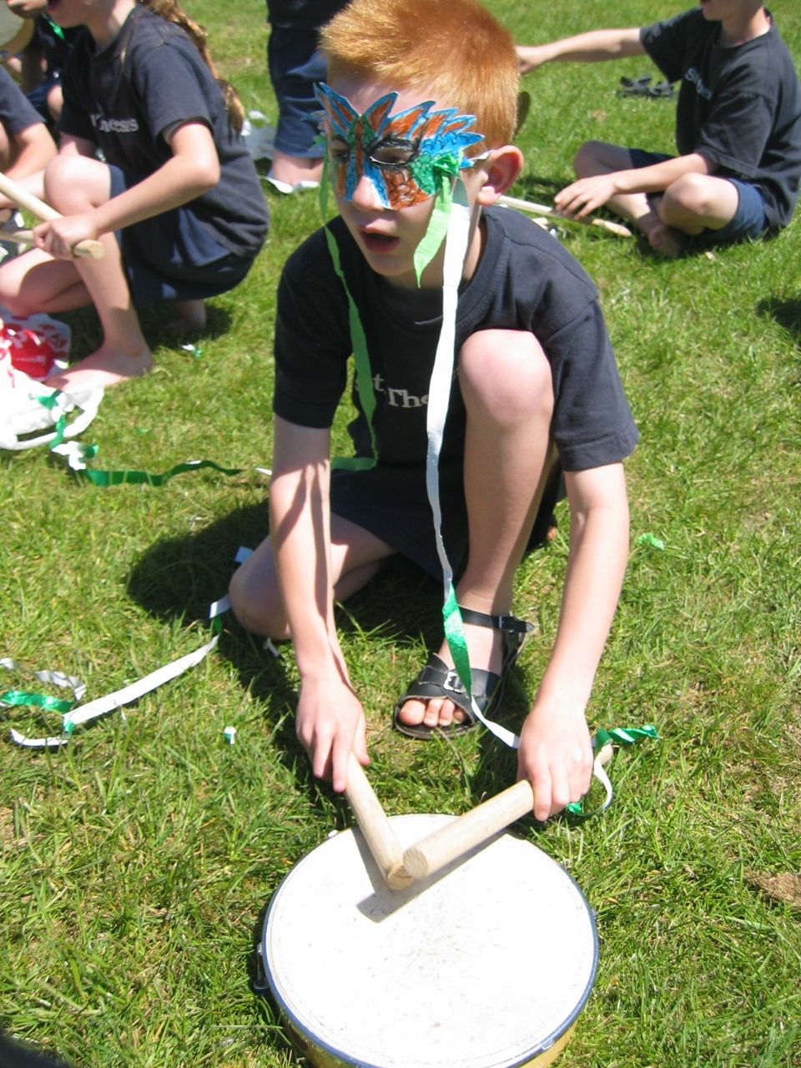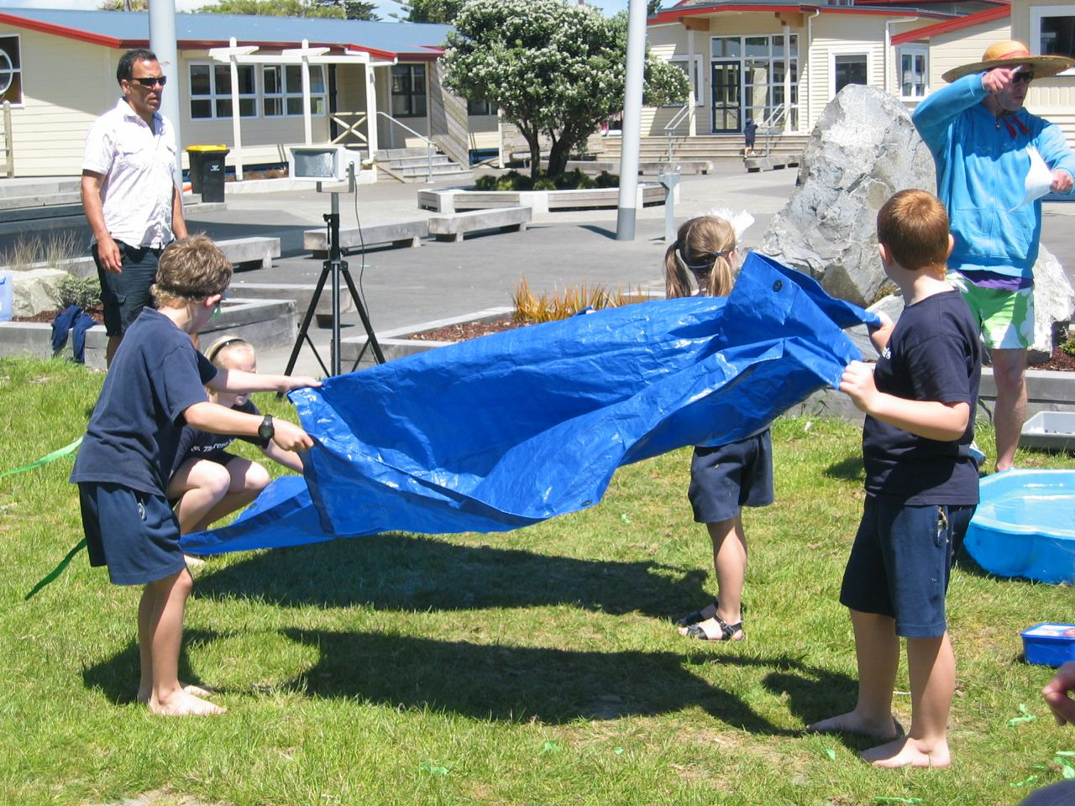

If a composition is very complicated, it pays off to create a visual drawing (using oil pastels) of the composition and/or to use one of the students as the conductor to signal with arm and body movements, who is to make a sound and to indicate silence. This offers a great opportunity for students to develop leadership skills and to improve their ability to listen.

Step 6: Rehearse the soundscape on its own, and rehearse it in the dramatic context of movement, actions or dialogue.

